Reference Answer Power BI 24-25 February 2025
Part 3: Data Modelling

Part 4: DAX Formula
CC = Create Column
CM = Create Measure
CT = Create Table
([Table Name]) example (Sales)
CC (Sales)
TS Value = IF(
Sales[Units Sold]<=50,// ini logic
"<=50",
IF(Sales[Units Sold]<=100,
"<=100",">100"
)
)

CM
Total Rev = SUMX(
Sales,
RELATED(Products[Price])*Sales[Units Sold]
)
// Fungsi RELATED digunakan untuk memanggil value yg sama berdasarkan Product ID

CC
# Show revenue per transactions
Rev Test = RELATED(Products[Price])*Sales[Units Sold]

CT
Calendar = CALENDAR(
DATE(YEAR(MIN(Sales[Order Date])),1,1),//Start date
DATE(YEAR(MAX(Sales[Order Date])),12,31)//End date)

CC
(Calendar)
Month = FORMAT('Calendar'[Date],"mmm")
CC
(Calendar)

Month = FORMAT('Calendar'[Date],"mmm")

#Untuk sort data by month order
#Sort column Month by MonthNumber

CC
(Calendar)
PH = LOOKUPVALUE(
'PH 2019'[Event],// Desired column
'PH 2019'[Date],//Reference in lookup table
'Calendar'[Date]) // Reference in output table

CC – Calendar
Untuk fiscal year bermula April

Quarter = "Q"&INT(MOD(MONTH('Calendar'[Date])-4,12)/3)+1

Option 2 column PH
CC
(Calendar)

Holiday =
LOOKUPVALUE('PH 2019'[Event],'PH 2019'[Date],'Calendar'[Date],"No Holiday")

CC
(Calendar)

Is Weekend = IF(
WEEKDAY('Calendar'[Date],2)>5,
"Yes","No"
)

CC
(Calendar)

Day = FORMAT('Calendar'[Date],"ddd")

CC
(Calendar)

Working Day =
SWITCH(TRUE(),
('Calendar'[PH]="No Holiday"||
'Calendar'[PH]="New Year's Day")&& 'Calendar'[Is Weekend]="No",
"Working Day","Holiday"
)
#Jika ada PH tertentu adalah cuti, tambahkan arguement ||
CM
(Measure)
Rev Prev Month = CALCULATE(
[Total Rev], //Value to evaluated)
PREVIOUSMONTH('Calendar'[Date])
)
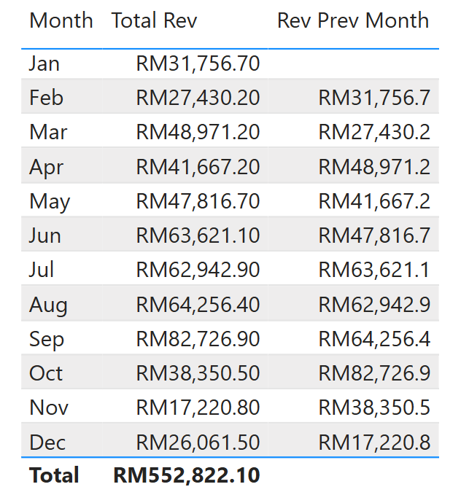
CM
(Measure)
Diff Rev Month = [Total Rev]-[Rev Prev Month]
CM
(Measure)
AVG by Month =
VAR ByMonth = CALCULATE([Total Rev],ALL('Calendar'[Date]))
RETURN
DIVIDE(ByMonth,DAY(MAX('Calendar'[Date])))

CM
(Measure)

%Rev By Month =
VAR ByMonth = CALCULATE([Total Rev],ALL('Calendar'))
RETURN
DIVIDE([Total Rev],ByMonth)

CM
(Measure)

No of Transaction = COUNTROWS(Sales)

